

Contents

Tone of Voice

Typography

Color

Grids

Concept/ Mind Maps

Imagery

Wire Frame

Imagery: Veer.com

Final Design

Note

Hi Aoife, Thank you very much for teaching me as I really enjoyed this class.

I leant a lot about different designs ad what and when to use them.

Sorry if any of the spelling or grammar is off as I’m dyslexic but I went through it and got my software to as well ☺.

Any way I couldn’t get my blog to work with the pdf creator so I copied and pasted it into word.

These are the ones in the list we studied and you told us to do the ones we studied ☺

The blog can be found on <http://www.r00102430.blogspot.ie>

# Tone of Voice

The tone of voice I want is to be colorful, fun and most importantly minimal and highly modern design.

I want to use tin letters and fonts — and after a bit, I want the style to highlight different parts and headline to the website. Like reading a newspaper. It’s quite effective how hovering reveals a sample image of each project; it almost jumps out of the at the user. I want the website to show how type can be used as graphic elements and incorporated into a design.

A great example is seen below, of home text is highlighted and changed.  
I want a mixture between this, a newspaper and super clean design.  
So as the blog goes on I will pick colors and make this design my own by changing it.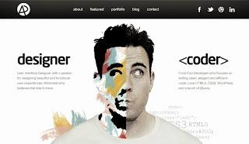

In my tone of voice I want to be friendly while also profitability. I want tell my story of how I won my awards and worked for different companies.

# Typography



First impressions are lasting impressions.

Typography helps to create an experience for users before they’ve even read a word or clicked a button. It shows the user who is behind the website and what you’re about.





I am after a mixture between a new headline and Minimal design.

The I picked in the end was Geo Sans Light because it gives off the extract impression I want , Simple , clean, thin and neat. While in the same point it also has a great impression and look on bold colors. So that is something I will have look into next. It gives off the right impression for my website. See to the right for what it will look like.

The font I pick is really important. As it can change the tone of voice and the impression that is given out to my visitors.

So my top 3 choices are the following and can be seen below and [here](http://www.dafont.com/theme.php?cat=501).

An example of what it will look is below. (As I can see, my version for my website is becoming clearer by the day)

# Color

Kulor Platte

The type of color plate I like are the following for my tone of voice for modern clean minimal coder. All this was found after many try’s on Color and messing around until I found my tone to match my design.

Which are all found [HERE](https://kuler.adobe.com/windows-8-art-colors/).

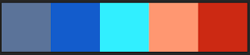



My Platte

But after more research into colors and my tone of design, I came across a website called <http://flatuicolors.com/>.

The other Platte gave me the right track to what I wanted but I changed and tweaked the colors to my vision.

So after some tweaking around I came across the following Platte That I really like a lot.

The colors I picked was the following

Background: #ebebeb;

Buttons: #2980b9;

Text: #34495e;

Headers: #2ecc71;

Links: #e67e22;

But for the background, I want to use a frosted background, to go behind all the text and information. See right.

Going for a Text based information and my photo in the middle. With headlines too.

This is the tone I want to give but maybe with a real image? Who knows, but more research is needed.

# Grids

I picked the column layout as I chosen for my design. 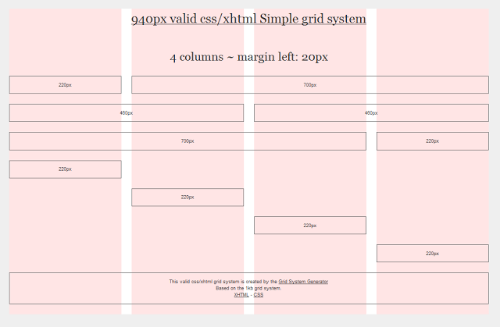

As I talked about in my previous posts, that I liked Minimal design.

With that being said I picked the website because I can split the website into four columns or the 1 large columns 700 pxs and a side menu for 22pxs.Leading into a clean but simple design for my content. Making simple easy and clean, trying to stick to my tone of voice and showing my creative side.

## **Details**

It is a 2-4 grid system with a width of 960px. It can also be spilt into 4 columns of 22pxs each too.

## **Colors**

The colors I picked was the following

Background: #ebebeb;

Buttons: #2980b9;

Text: #34495e;

Headers: #2ecc71;

# Concept/ Mind Maps

Mind Map (Click to Enlarge)

In class today we have to brainstorm what a programmer does.  I brain stormed about the following topics. Computer Programmer, Coder and Minimal Design.

Doing the brain storm gave me the topic and ideas I need to start design my website. With focus on coder and minimal design, with all the key words involved with it. As it is important to enjoy whatever you are doing and I enjoy coding and design.

Below is my brain storms.

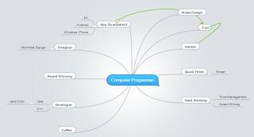

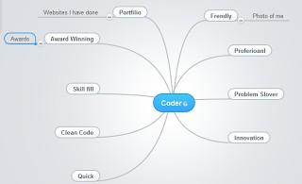

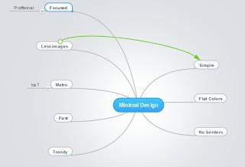

# Imagery

### **The imagery I want to invoke in my website is the following people. I want a mixture between clean design and striking imagery.**

The imagery I picked is below. It gives the impression of clean design while also having a strong impression. It’s clean simple and strong. I can’t really say much but let the pictures speak for them self. It shows my idea for my concept in an abstract manner.

For example to the image below shows off the details I want to show off in the faded.

## Main Image

To your right is the laptop, the coder’s work place if you will and driving force behind the tools they use to create the web. That's why this image was important for me to get right.  
The image shows the mixture behind clean design and piece designer willing to work from around the world.  
The image on the right is an example of the type of smaller images I want on the website to mix between clean design and high quality image that is smart modern web design.  
When you look to the right, you see the image but with the slightest of colors and shapes used. This is the idea I’m trying to get out onto users, clean design and simple shape principles.  
  
**So these are the images I want to give off for my impression.**

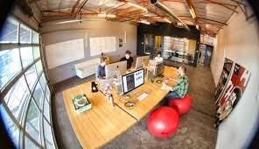

Content Development

Below is the content for my webpages to show the friendly nature and store for what I want to give off to visitors about me. Showing my skills and information along with my work from my awards. This text will give a personal touch and fit it with my tone of voice.

## Home Page

HI IM ROBERT GABRIEL

I'M A SOFTWARE AND WEB DESIGNER WHO HAS WON MULTIPLY AWARDS

Read about my story as an award winning designer.

About Page Content

Project bird is the website of Robert Gabriel.

Who is a twenty year old dyslexic boy who discovered programming and computers at the tender age of 16?

At a young age I was diagnosed (but not officially) with a form of learning disable at the age of seven or eight years old.

While growing up most of my of primary school life, teachers thought I was simply lazy or not the brightest. I always found it hard to read or simply write my homework. I remember being shouted at front of all my friends by the headmaster for misspelling cat.

As I entered secondary school (High school) I found it hard to write and read in Irish and French. I failed these subjects for two years along with my grades slipping because of it.

It was the parent teaching meeting of my second year in high school wear my teacher told my parents that I should drop out of school because I wasn't smart enough. My mother wasn't happy with this at the slightest and demanded to meet the head master who ignored her and me at first.

She made sure I wasn't ignored and asked and made sure I got tested for a learning disability

Let’s move forward 2 to 3 months, I got tested by a teacher that will always have a place in my heart. It turned out I had dyslexia and are case. I simply fell through the cracks in my primary school.

I was allowed drop both French and Irish, My grades started climbing to A and B's.

Let’s jump to 8 months to 3rd year of my high school.

In Irish high schools, come third year you take two state exams called the per-junior cert and the junior cert.

Well some teachers though I was still slower than normal. SO I took my prep’s and got my results in class in English. I got the rest in the class because I had a reader during the exam which helped me understand the exam. I was super proud until my English teacher told me in front of everyone I didn't earn or deserved my result.

This put me in a state of shock:-o

# Wire Frame

As it’s a website wire frame is also known as a page schematic or screen blueprint or a simple prototype, is a [visual guide](http://en.wikipedia.org/wiki/Visual_guide) that represents the skeletal framework of a [website](http://en.wikipedia.org/wiki/Website).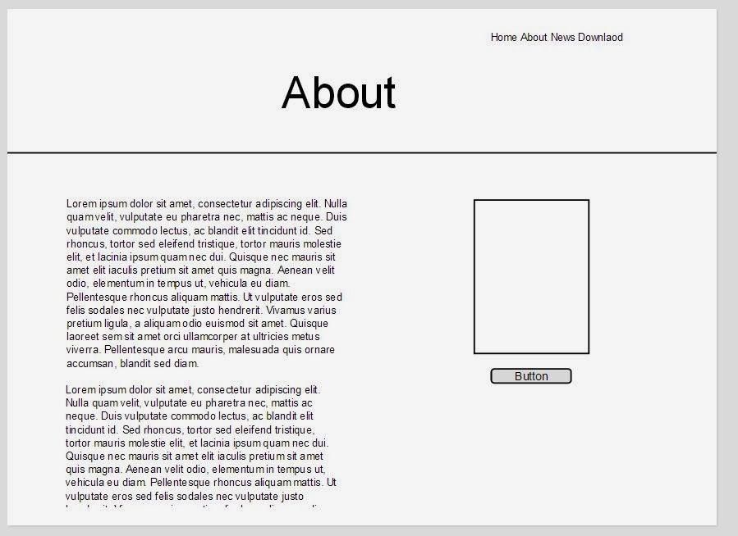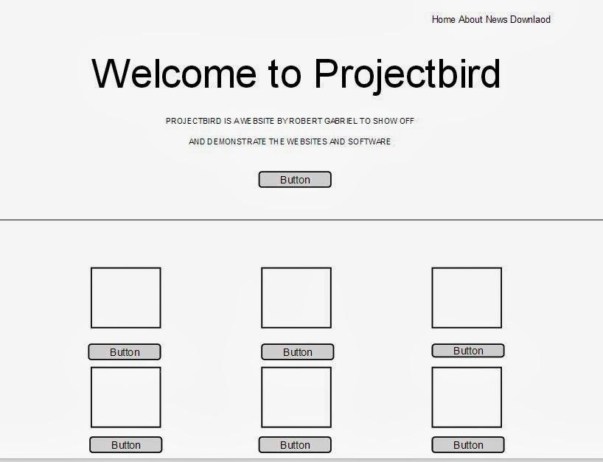

I used the website [Mosque](https://moqups.com/) to develop my wire frames and as you can see below.

I have used my method of simple design.

I came to the idea that I will have to build this in html and cms as Photoshop can’t get across what I want.

Seen on the right is my rough wire frame design. It can be seen later in my final design what I’m trying to do.

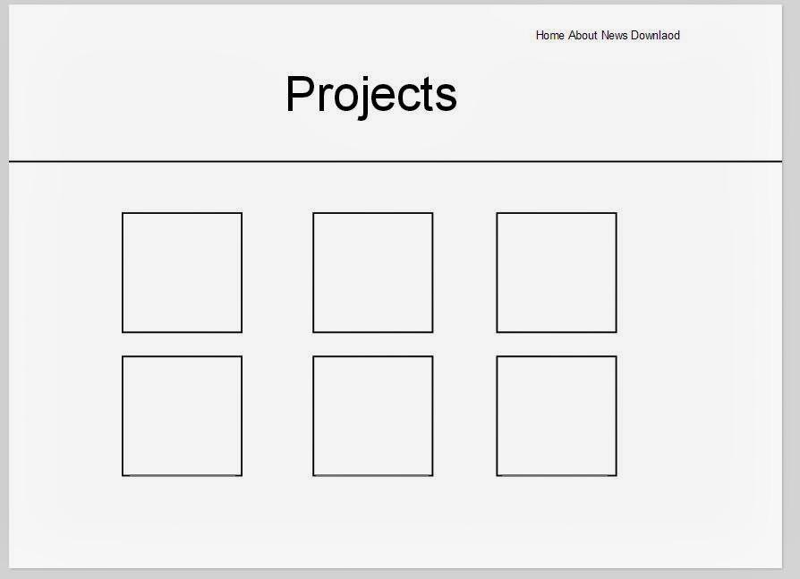

# Imagery: Veer.com

The imagery I picked is below which where all taken for veer.com. It gives the impression of clean design while also having a strong impression. It’s clean simple and strong. I can’t really say much but let the pictures speak for them self. It shows my idea for my concept in an abstract manner.

Simple and powerful yet still clean. Matching my tone of voice and keeping it personal.

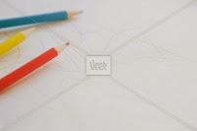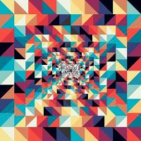  
  
  
  


# Final Design

After many weeks of design and learning about design. My design can be seen below. If you look though my posts you can see my thoughts into coming into my design.

Using many design types and features I have talked about though the weeks can be seen below. My choice of colors, images, effects and text. All this can be seen below and reasons in section 2 of the blog.

So below my design gives off an impression of my own personality and simple clean design.

The use of text to highlight information and while images show off parts of the site using colors.

What I get from and take away from studying visual design is that design changes until you know what's right and needed.

As I can say is from the research I have seen how different designs work. Making my eye grow and making me a better designer.

Anyway have a look, as I’m over the moon of the design and how it came out. As it reached everything I wanted from my tone of voice and the colors I wanted right down to the information.

## Home Page

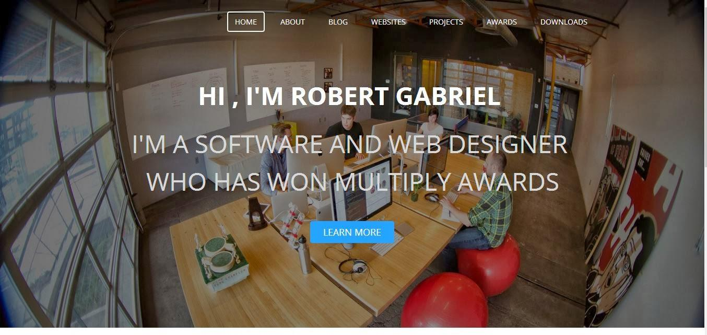

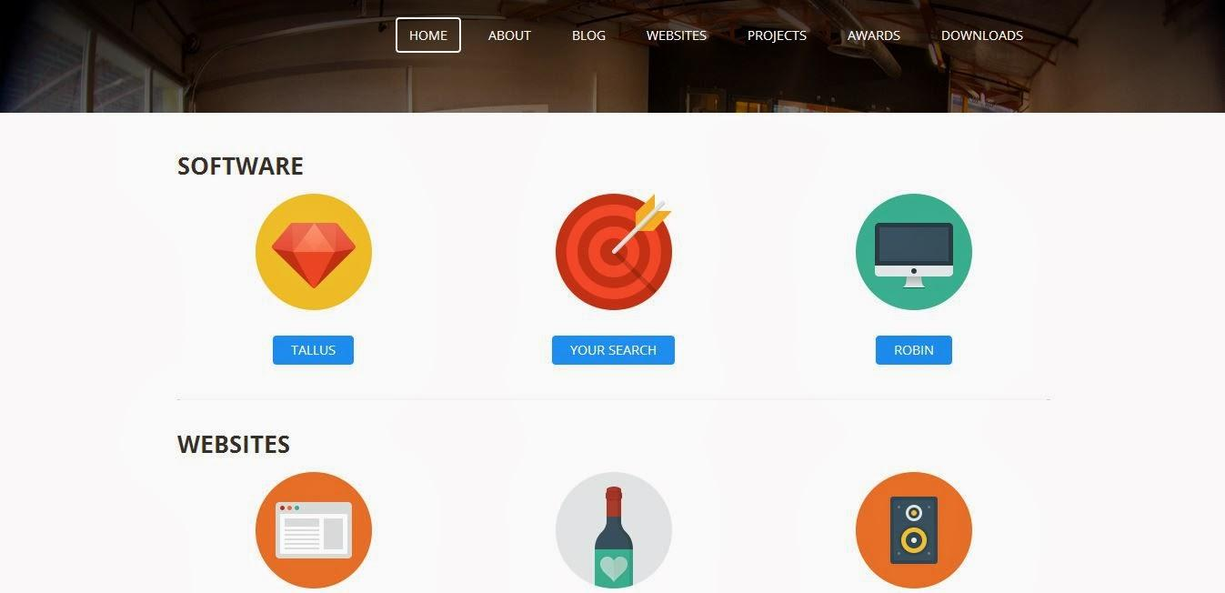

**About Page**

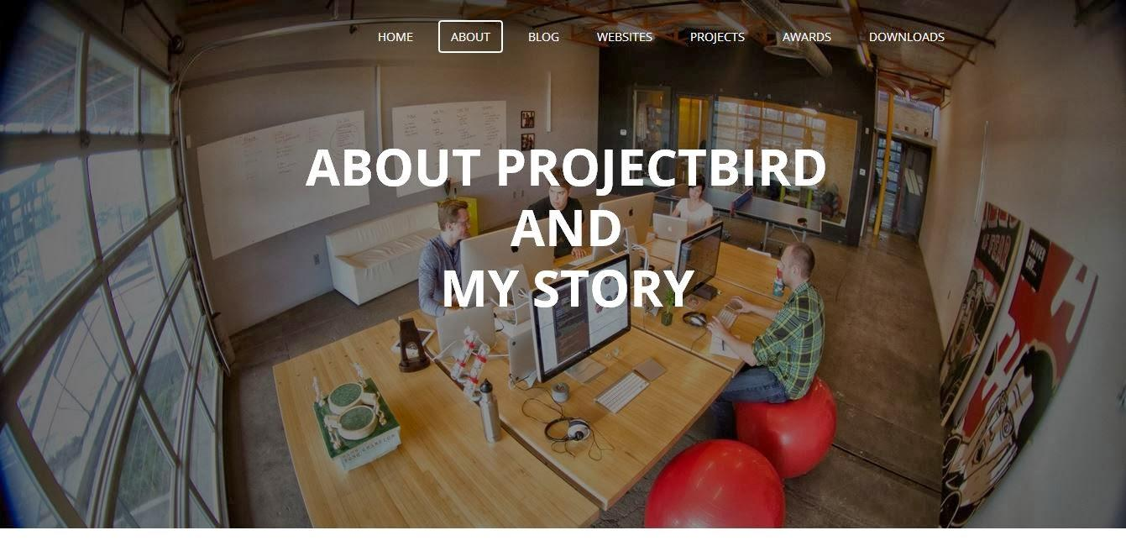

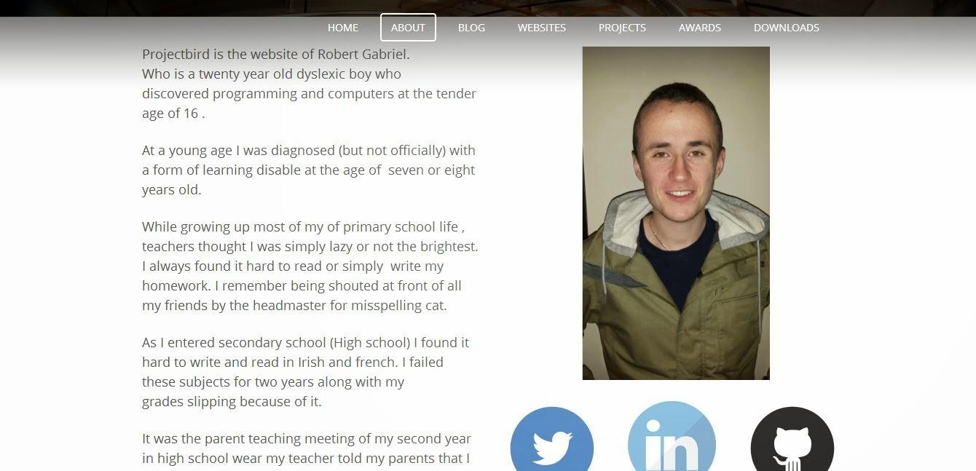

## Awards Page

